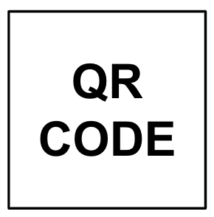
*
Colorimetric LAMP MM - NEB M1804  Lot:  EXP (MM-YY):  Put New in Use:  Location: Name:  Date and Time: |  |  |  | Log Link: SOP-102-B_1 {SITE}  Name:  Date and Time:

Reaction Mix Prep
- Thaw PGS and CLAMP MM
- Vortex PGS and CLAMP MM for 3s, centrifuge/shake down
- Add CLAMP MM to PGS tube (or new 1.5mL tube for custom amount)
- Vortex for 10s and centrifuge/shake down
- Add 23µL of reaction mix per well {at bottom, no blowout, no tip touch}
* optional use reservoir and multichannel
- Check volumes (look at pink liquid) by lifting plate or strip tubes out of rack
- Label with Reaction Mix ID
- EXPIRATION of Reaction Mix: 4 weeks after prep or if it becomes discolored.

 |  |  |  |  | 48  24  16  8 | 550  275  183  92 | 655  328  218  109
Name | Date  + Time | Reaction Mix ID  (RM_MMDD-1) | CLAMP MM  TubeID (_MMDD-X) | PGS  LOT# + EXP | Num  Rxns | PGS  µL | CLAMP MM µL

 |  |  |  |  | 48  24  16  8 | 550  275  183  92 | 655  328  218  109
Name | Date  + Time | Reaction Mix ID  (RM_MMDD-1) | CLAMP MM  TubeID (_MMDD-X) | PGS  LOT# + EXP | Num  Rxns | PGS  µL | CLAMP MM µL

